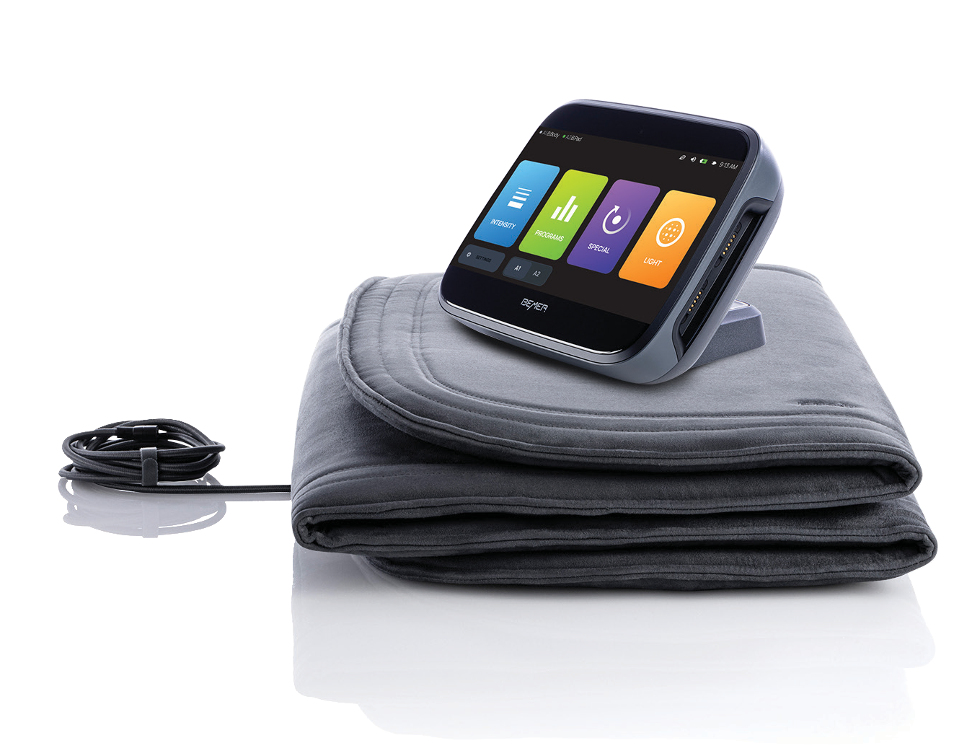

BEMER does not provide any medical advice or services. This device is not intended to diagnose, treat, cure or prevent any disease. It should not be used for any purpose other than
as described in the user manual. Please consult your own healthcare provider if you have any medical issues.

© 2024 BEMER USA, LLC
INTRODUCING

The BEMER

Basic-Set — for a limited time only.

Poor microcirculation may be the root of many health problems.
BEMER’s one-of-a-kind electromagnetic energy regulation temporarily increases local blood circulation and stimulates healthy muscles to help you reach your apex physical condition naturally. Just two 8-minute sessions a day produce noticeable results.
Limited Time Offer!
The Basic-Set will be available on April 2nd
Basic-Set EVO with
B. Box Evo and B. Body Evo
Quantities Are Limited!
$4290*
USD
*Sales tax not included in promotional price.

